Chapter 16, Problem 82.

Calculate the gain H(s) = V_{o}/V_{s} in the op amp circuit of Fig. 16.100.

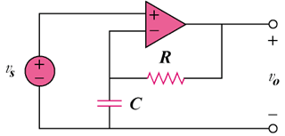

Figure 16.100
For Prob. 16.82.

